Rhyne Park Girls Softball

Fall Ball season News: Getting Started

First practice of the season will be Saturday, August 24th at the Rhyne Park fields. For those age groups that will have multiple teams, the practice time scheduled for August 24th will be a skills assessment day. The purpose of the skills assessment is to allocate players to the appropriate team in order to create the best learning environment for all players, as well as competitive teams in each age group. At the skills assessment, the girls should expect to participate in basic softball drills including batting, throwing, catching, and running.
August 24th practice times are now posted on www.RhynePark.org.

Meet your new executive board members
As we begin the new season, we wanted to take the opportunity to introduce your new executive board members. Samantha French will be serving Rhyne Park as the new President, and Wendi Fassbender will be serving as the new park secretary. Sam and Wendi’s daughters have been playing at the park for several seasons, and they are excited about the opportunity to assist with new park initiatives and organization. If you have questions at the park or at any time, feel free to ask either of them for assistance.
Buster Ray has taken on the role of park Treasurer. Buster has been at Rhyne Park for 3 years serving as park President and coaching the 16U travel team, the Rhyne Park Raptors.
Connie Kearney, previously Treasurer, will now serve as Vice President at the park. She has been coaching at Rhyne Park for 12 years and has served on the executive board for the last 4.

Contact us at either rhynpark.president@gmail.com or rhynepark.secretary@gmail.com
What’s new at Rhyne Park

This season we are adding a little color to the standard uniforms with matching softball socks for each girl! Additionally, new batting helmets will be purchased to create a consistent look, while ensuring our girls have the safest equipment on the market.
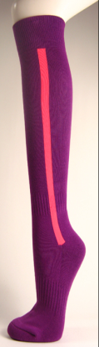

concessions
In the summer of 2014, the park will be undergoing some renovations, including new fences and two full sized infields in the grassy area between the two fences of field # 2. This will allow for additional practices to be held at one time, creating flexibility.

Concession signup will be available online again this year. You will be receiving communication from Jodi Stultz, who will be your contact for concession signup.
For those of you who are new to the park, don’t forget that your $25 will be refunded directly to you after you work your 2 hour concession shift.
The concession stand will be offering some new snack choices this season including freeze pops and individual bags of chips.
In the months to come, look for new Rhyne Park spirit merchandise!
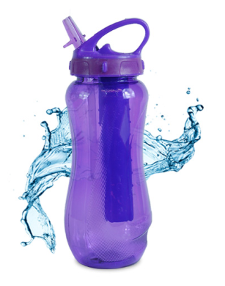
We are looking forward to seeing you at the park!

